


Technical Program Transfer Articulation Agreement Prescribed Curriculum: Western Dakota Technical College Environmental Engineering Technician (A.A.S.)
General Education Courses |  |  |  | 9 CREDIT HOURS
General Education Category | Credit Hours | Course ID | Course Title or Category
Written Communication | 3 | ENGL 101 | English Composition
Social Sciences | 3 | PSYC 101 | Psychology, OR Other Social Science (Goal 3) course
Mathematics | 3 | MATH 120 | Trigonometry (MATH 114 pre-req)
Science |  | Refer to “SDSMT Courses Taken While Jointly Attending WDT” section below

Required Courses |  |  |  | 48 CREDIT HOURS
Degree Requirement | Credit Hours | Course ID | Course Title
Science | 4 | BIOL 101/101L | Biology Survey I w/Lab
Science | 4 | MICR 231/231L | General Microbiology I w/Lab
 | 2 | AG 110 | Fundamentals in Soil Science
 | 2 | AE 250 | Mapping and GPS Technologies
 | 3 | AE 251 | Introduction to GIS
 | 3 | AE 252 | Surveying I
Agriculture, Architectural | 4 | EET 102 | Introduction to Environmental Sciences
Engineering, and | 4 | EET 102
Engineering, and | 3 | EET 140 | Laboratory Methods in Environmental Science
Environmental Engineering | 3 | EET 140
Environmental Engineering | 2 | EET 210 | Environmental Regulations & Hazmat Awareness
Technician | 2 | EET 210
 | 4 | EET 215 | Hydrology & Stream Field Methods
 | 3 | EET 220 | Water Treatment and Distribution
 | 2 | EET 225 | Air Quality
 | 3 | EET 251 | Environmental Geology
Technical Electives | 3 | EET 202 | Water Quality
Technical Electives | 3 | EET 235 | Construction Materials Sampling & Testing
Technical Electives | 3 | EET 260 | Wastewater Collection and Treatment

SDSMT Courses Taken While Jointly Attending Western Dakota Tech |  |  |  | 8 CREDIT HOURS
Course ID | Course Title | Credit Hours | Note
CHEM 112/112L* | General College Chemistry I w/ Lab | 4 | Replaces CHEM 106/106L required at WDT
MATH 123* | Calculus I | 4
*May be taken at SDSMT or any South Dakota Board of Regents institution
AAS Environmental Engineering Technician Degree Total:  Additional Credits Completed Toward BS Degree Requirements:  Total Credits Completed by End of AAS Degree: | 61 credit hours  4 credit hours  65 CREDIT HOURS  (42 Cr Apply to BS)

Post-Associate Degree Prescribed Curriculum: South Dakota Mines

Civil Engineering, Environmental Engineering Specialization (B.S.)

General Education Courses |  |  |  | 19 CREDIT HOURS
Category | Credit Hours | Course ID | Course Title or Category
Goal 1: Written Communication | 3 | ENGL 289 | Explorations in STEM Communications
Goal 2: Oral Communication | 3 | ENGL 279 | Communication in the STEM Workplace
Goal 3: Social Sciences-Civics | 3 | Select 1 course from | CIV 100, HIST 151, HIST 152, POLS 100, or POLS 210
Goal 4: Arts/Humanities | 6 | Select 2 courses from | Arts/Humanities (Goal 4) general education approved list
Goal 6: Natural Sciences | 4 | CHEM 114/114L | General College Chemistry II w/Lab

Major Required Courses |  |  | 41 CREDIT HOURS
 | Credit Hours | Course No. | Course Title
Engineering | 3 | EM 214 | Statics
Engineering | 3 | EM 331 | Fluid Mechanics
Engineering | 3 | CBE 217 | Chemical Engineering Material Balances
Engineering | 3 | CEE 284 | Applied Numerical Methods
Engineering | 3 | EM 321 | Mechanics of Materials
Engineering | 3 | CBE 222 | Thermodynamics
Engineering | 3 | CEE 336/336L | Hydraulic Systems Design w/ Lab
Engineering | 3 | CEE 316/316L | Construction Materials w/ Lab
Engineering | 3 | CEE 346/346L | Geotechnical Engineering I w/ Lab
Engineering | 3 | CEE 325 | Introduction to Sustainable Design
Engineering | 3 | CEE 426 | Environmental Engineering Unit Operations & Process
Engineering | 2 | CEE 463 | Concepts of Professional Practice
Engineering | 3 | CEE 427 | Environmental Engineering Biological Process
Engineering | 3 | CEE 489 | Capstone Design

Other Required and Elective Courses |  |  | 28 CREDIT HOURS
 | Credit Hours | Course No. | Course Title
Economics | 2 | IENG 301 | Engineering Economics
Mathematics | 4 | MATH 125 | Calculus II
Mathematics | 4 | MATH 225 | Calculus III
Mathematics | 3 | MATH 321 | Differential Equations
Mathematics | 3 | MATH 381 | Introduction to Probability & Statistics
Physics | 3 | PHYS 207 | Fundamentals of Physics I
Electives | 9 | Select from list | Department Approved Electives

Post-Associate Degree Total: | 88 CREDIT HOURS

Bachelor of Science – Civil Engineering Total: | 130 CREDIT HOURS

Technical Program Transfer Articulation Agreement (TPTAA) Guarantees & Limitations

GUARANTEES

Students who:
- complete the Associate of Applied Science – Environmental Engineering Technician degree prescribed curriculum at Western Dakota Technical College (WDT) exactly as it is identified in this articulation agreement, and
- have the degree conferred on their education record at WDT (post high school graduation), and
- earn a minimum cumulative grade point average (GPA) of 2.75 at WDT, and
- pass all 65 credits documented on page one (57 credits at WDT and 8 credits at South Dakota Mines (or other South Dakota Board of Regents institution), earning a grade C- or higher in each course

are guaranteed the following at the South Dakota School of Mines and Technology (South Dakota Mines):
- admission to South Dakota Mines
- admission to the Bachelor of Science – Civil Engineering, Environmental Engineering Specialization degree
- no more than 88 remaining credits at South Dakota Mines to meet the graduation requirements for the Bachelor of Science – Civil Engineering, Environmental Engineering Specialization degree.

LIMITATIONS
- This agreement is between the Associate of Applied Science – Environmental Engineering Technician degree at Western Dakota Technical College and the Bachelor of Science – Civil Engineering, Environmental Engineering Specialization degree at South Dakota Mines only.
- Students must meet all admission and application requirements at South Dakota Mines, including the submission of all required documentation by stated deadlines. Students are advised to contact the Office of Admissions at the South Dakota Mines early in their transfer planning.
- Student must have a cumulative grade point average (GPA) at Western Dakota Technical College of 2.75 or higher
and only courses with grades of C- or higher are guaranteed to be accepted in transfer by South Dakota Mines.
- The credit and course transfer guarantees described in this agreement apply to the Associate of Applied Science
  - Environmental Engineering Technician degree at Western Dakota Technical College and the Bachelor of Science
  - Civil Engineering, Environmental Engineering Specialization degree at South Dakota Mines. If the student changes majors at Western Dakota Technical College or at South Dakota Mines, the student is no longer covered by this Articulation Agreement and none of the Guarantees of the Agreement apply.
- Students utilizing any form of transfer credit, including but not limited to credit awarded from other higher education institutions, standardized exam (CLEP, AP, DSST, etc.), prior learning assessment (military, certifications, ACE recommended credit, portfolio, challenge exam, work experience equivalent credit) to satisfy any associate degree requirements will have those credits evaluated by South Dakota Mines. Should South Dakota Mines not accept the transfer credits accepted by Western Dakota Technical College, the student will be required to make up the credit deficiency at South Dakota Mines.
- No course substitutions are allowed for the courses listed in the Prescribed Curriculum for the associate degree at Western Dakota Technical College.

TPTAA CONTACT INFORMATION
South Dakota Mines Western Dakota Technical College
Office of the Provost Academics
605.394.2256 605.718.2905
Provost@sdsmt.edu Tiffany.Howe@wdt.edu

RENEWAL, REVISION, and TERMINATION
- This Technical Program Transfer Articulation Agreement (TPTAA) shall be in effect July 1 – June 30 each year and will automatically renew annually unless action is taken by South Dakota Mines or Western Dakota Technical College to terminate or modify it.
- The South Dakota Mines Civil Engineering Department Head and the Western Dakota Technical College Environmental Engineering Technician Program Director will collaborate to review the content of the associate and bachelor degrees on a three-year cycle to ensure this TPTAA is still appropriate.
- South Dakota Mines and Western Dakota Technical College each reserve the right to seek revision of this agreement at any time.

Revision of any content of the agreement (except Appendices content) will be approved by each institution and result in a new agreement being signed, with copies retained by each institution.
  - Revision to any Appendices will be communicated to each institution, but do not need to be approved by each institution and will not result in a new agreement being signed by each institution.
- South Dakota Mines and Western Dakota Technical College each reserve the right to seek termination of this agreement at any time.
- Should the agreement be terminated, each institution agrees to collaborate and engage in appropriate plans to notify and work with impacted students, providing a minimum one-year advance notice of termination.

APPROVALS

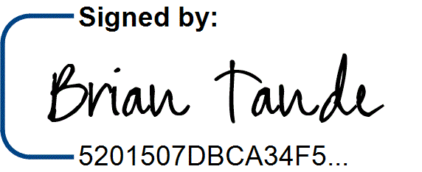
8/1/2025

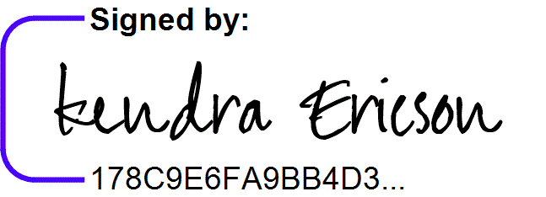
7/31/2025

Brian Tande, Ph.D. Date Kendra Ericson, Ph.D. Date President President
South Dakota Mines Western Dakota Technical College
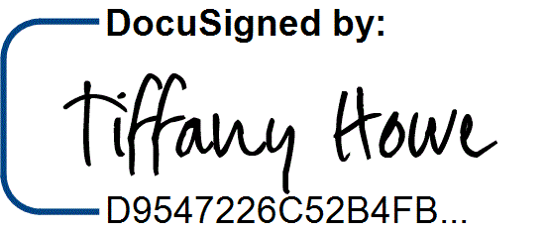
Brian.Tande@sdsmt.edu Kendra.Ericson@wdt.edu

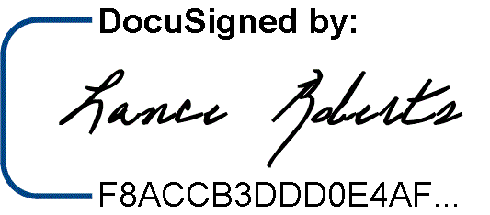
8/1/2025
7/29/2025

Lance Roberts, Ph.D. Date Tiffany Howe Date Provost and Vice President for Academic Affairs Vice President for Teaching and Learning South Dakota Mines Western Dakota Technical College
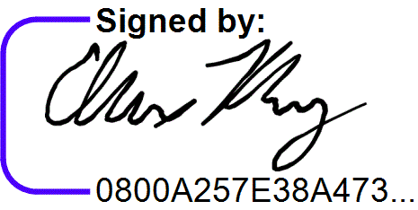
Provost@sdsmt.edu Tiffany.Howe@wdt.edu

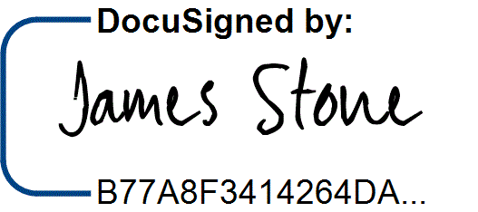
7/31/2025
7/29/2025

James Stone, Ph.D. Date Alex Rosburg Date Department Head Environmental Engineering Program Director
South Dakota Mines Western Dakota Technical College
James.Stone@sdsmt.edu Alex.Rosburg@wdt.edu

Appendix A: Course Sequence


Docusign Envelope ID: FB906225-D02E-4109-BD65-DF4A48EC3648
Course Sequence: Western Dakota Technical College

Environmental Engineering Technician (A.A.S.)
- Option 1: College Algebra Ready

Semester | Course No. | Course Title | Credit Hours | Completed
Freshman Year  First Semester | AE 250 | Introduction to Mapping/GIS | 2
Freshman Year  First Semester | BIOL 101/101L | Biology Survey I w/Lab | 4
Freshman Year  First Semester | PSYC 101* | General Psychology | 3
Freshman Year  First Semester | EET 102 | Introduction to Environmental Sciences | 4
Freshman Year  First Semester | MATH 114 | College Algebra | 3
Total Credits 16

Semester | Course No. | Course Title | Credit Hours | Completed
Freshman | EET 140 | Laboratory Methods in Environmental Science | 3
Year
Year | EET 225 | Air Quality | 2
Second
Second | EET 251 | Environmental Geology | 3
Semester
Semester | ENGL 101* | Composition I | 3
 | MAT 120 | Trigonometry | 3
 | CHEM 112/112L* | General College Chemistry I w/Lab (enrolled at SDSMT) | 4
Total Credits 18 (14 WDT)

Semester | Course No. | Course Title | Credit Hours | Completed
Summer Between  Yr 1 and Yr 2 | MATH 123* | Calculus I (enrolled at SDSMT) | 4
Total Credits 4 (0 WDT)

Semester | Course No. | Course Title | Credit Hours | Completed
Sophomore Year  First Semester | AE 252 | Introduction to Surveying | 3
Sophomore Year  First Semester | AG 110 | Fundamentals in Soil Science Hydrology | 2
Sophomore Year  First Semester | EET 215 | Hydrology & Stream Field Methods | 4
Sophomore Year  First Semester | EET 220 | Water Treatment and Distribution | 3
Sophomore Year  First Semester | MICR 231/231L | General Microbiology w/Lab | 4
Total Credits 16

Semester | Course No. | Course Title | Credit Hours | Completed
Sophomore | AE 251 | Introduction to GIS | 3
Year
Year | EET 210 | Environmental Regulations & Hazmat Awareness | 2
Second
Second | EET 202 | Water Quality (Technical Elective) | 3
Semester
Semester | EET 235 | Construction Materials (Technical Elective) | 3
 | EET 260 | Wastewater Collection and Treatment (Technical Elective) | 3
Total Credits |  |  | 14

BS Degree-Applicable General Education Coursework Total (6 WDT + 8 SDSMT):  AAS Major and Elective Coursework Total:  Total Credits Completed by End of Associate Degree: | 14* credit hours  54 credit hours  68 CREDIT HOURS

Docusign Envelope ID: FB906225-D02E-4109-BD65-DF4A48EC3648
Course Sequence: Western Dakota Technical College

Environmental Engineering Technician (A.A.S.)
- Option 2: Trigonometry Ready

Semester | Course No. | Course Title | Credit Hours | Completed
Freshman Year  First Semester | AE 250 | Introduction to Mapping/GIS | 2
Freshman Year  First Semester | BIOL 101/101L | Biology Survey I w/Lab | 4
Freshman Year  First Semester | ENGL 101* | Composition I | 3
Freshman Year  First Semester | EET 102 | Introduction to Environmental Sciences | 4
Freshman Year  First Semester | MATH 120 | Trigonometry | 3
Total Credits |  |  | 16

Semester | Course No. | Course Title | Credit Hours | Completed
Freshman | EET 140 | Laboratory Methods in Environmental Science | 3
Year
Year | EET 225 | Air Quality | 2
Second
Second | EET 251 | Environmental Geology | 3
Semester
Semester | CHEM 112/112L* | General College Chemistry I w/Lab (enrolled at SDSMT) | 4
 | MATH 123* | Calculus I (enrolled at SDSMT) | 4
Total Credits 16 (8 WDT)

Semester | Course No. | Course Title | Credit Hours | Completed
Sophomore Year  First Semester | AE 252 | Introduction to Surveying | 3
Sophomore Year  First Semester | AG 110 | Fundamentals in Soil Science Hydrology | 2
Sophomore Year  First Semester | EET 215 | Hydrology & Stream Field Methods | 4
Sophomore Year  First Semester | EET 220 | Water Treatment and Distribution | 3
Sophomore Year  First Semester | MICR 231/231L | General Microbiology w/Lab | 4
Total Credits 16

Semester | Course No. | Course Title | Credit Hours | Completed
Sophomore | AE 251 | Introduction to GIS | 3
Year
Year | EET 210 | Environmental Regulations & Hazmat Awareness | 2
Second
Second | PSYC 101* | General Psychology | 3
Semester
Semester | EET 202 | Water Quality (Technical Elective) | 3
 | EET 235 | Construction Materials (Technical Elective) | 3
 | EET 260 | Wastewater Collection and Treatment (Technical Elective) | 3
Total Credits |  |  | 17

BS Degree-Applicable General Education Coursework Total (6 WDT + 8 SDSMT):  AAS Major and Elective Coursework Total:  Total Credits Completed by End of Associate Degree: | 14* credit hours  51 credit hours  65 CREDIT HOURS


Course Sequence: South Dakota Mines – Fall Semester Start

Civil Engineering – Environmental Engineering Specialization (B.S.)

Semester | Course No. | Course Title | Credit Hours | Completed
SDSMT  First Semester  - FALL | CHEM 114/114L | General College Chemistry II w/Lab | 4*
SDSMT  First Semester  - FALL | EM 214 | Statics | 3
SDSMT  First Semester  - FALL | MATH 125 | Calculus II | 4
SDSMT  First Semester  - FALL | PHYS 207 | Fundamentals of Physics I | 3
Total Credits 14

Semester | Course No. | Course Title | Credit Hours | Completed
SDSMT | CBE 217 | Chemical Engineering Materials Balance | 3
Second
Second | MATH 225 | Calculus III | 4
Semester -
Semester - | EM 331 | Fluid Mechanics | 3
SPRING
SPRING | EM 321 | Mechanics of Materials | 3
 |  | Arts/Humanities (Goal 4) General Education Elective | 3*
 |  | Total Credits | 16

Semester | Course No. | Course Title | Credit Hours | Completed
SDSMT | CBE 222 | Thermodynamics | 3
Third
Third | MATH 321 | Differential Equations | 3
Semester -
Semester - | CEE 284 | Applied Numerical Methods | 3
FALL
FALL | CEE 336/336L | Hydraulic Systems Design w/Lab | 3
 | CEE 316/316L | Construction Materials w/Lab | 3
 |  | Total Credits | 15

Semester | Course No. | Course Title | Credit Hours | Completed
SDSMT | CEE 325 | Introduction to Sustainable Design | 3
Fourth
Fourth | CEE 426 | Environmental Engineering Physical Chemical Processes | 3
Semester -
Semester - | ENGL 279 | Communication in the STEM Workplace | 3*
SPRING
SPRING | IENG 301 | Engineering Economics | 2
 |  | Arts/Humanities (Goal 4) General Education Elective | 3*
 |  | Total Credits | 14

Semester | Course No. | Course Title | Credit Hours | Completed
SDSMT | CEE 346/346L | Geotechnical Engineering I w/Lab | 3
Fifth
Fifth | CEE 463 | Concepts of Professional Practice | 2
Semester -
Semester - | CEE 427 | Environmental Engineering Biological Processes | 3
SPRING
SPRING | ENGL 289 | Explorations in STEM Communication | 3*
 |  | Department Approved Electives | 3
 |  | Total Credits | 14

Semester | Course No. | Course Title | Credit Hours | Completed
SDSMT | CEE 489 | Capstone Design | 3
Sixth
Sixth | MATH 381 | Introduction to Probability & Statistics | 3
Semester -
Semester - |  | Department Approved Electives | 6
SPRING
SPRING | Select 1 course from | Social Science (Goal 3) CIV 100, HIST 151, HIST 152, POLS | 3*
 | Select 1 course from | 100, or POLS 210 | 3*
 |  | Total Credits | 15

*General Education Coursework Total:  Major and Elective Coursework Total:  South Dakota Mines Coursework Total: | 19 credit hours  69 credit hours  88 CREDIT HOURS

